PHOENIX SAIL & POWER SQUADRON

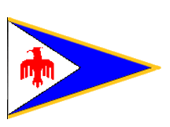

TRIBAL KNOWLEDGE



2011

INTRODUCTION

Tribal knowledge is any unwritten information that is not commonly known by others. Without attention it can flourish in any organization. This document is an attempt to rectify that and put into words that which often goes without saying be it intentional or not.

Tribal knowledge is one of the major impediments to member involvement. Members would get involved, but they just don’t know enough about what is going on. The intent of this document is to remove or resolve any questions members might have about what happens when, where, and why. That only leaves the “who”, but when you have three of the four questions answered the “who” are those that like to get involved (the fun place to be).

The purpose of this document is to stomp out Tribal Knowledge. It is an oxymoron in itself, as if it were successful in achieving its purpose there would be no need for this document. However, Tribal Knowledge will exist in someway and will never be totally eliminated, so we must proceed. This document is definitely a work in progress as a few incomplete pages will attest to.

If you find things in this document that make you think “I knew that”, good you are well on your way to becoming an informed member. If on the other hand, there is a lot you didn’t know, read on. You will become a “know it all”, and in this case, that is a good thing!

Special thanks go to Past Squadron Commanders Paul Schoonover, Les Ormsby, and Lee Whitehead for their contributions to this effort. We invite any and all squadron members to lend a hand in the objective we have set out to achieve. Enjoy your squadron and its heritage.

Remember only elephants can stomp out forest fires! It is up to us to do the rest.

TABLE OF CONTENTS

What is the Phoenix Sail & Power Squadron? 1
What is the origin of the Phoenix Sail & Power Squadron? 2
What is the Squadron Charter? 3
What is the Squadron Burgee? 5
USPS Uniforms 7
What are Merit Marks? 8
What are the Squadron Operating Documents? 9
Squadron Bylaws 9
Policies and Procedures 9
Awards 9
Job Descriptions 9
Squadron Meetings 10
General Membership Meetings 10
Annual Meeting 10
Change of Watch 10
Executive Committee Meetings 10
What is the origin of the Awards given out at Squadron meetings? 11
Educator of the Year 11
Thunderbird Award 11
John Yount Sheer Genius Award 11
Traditional Squadron Rendezvous and Parties 12
Katherine Landing Rendezvous 13
What is the Katherine Landing Poker Run? 14
Past Commander’s BBQ 15
OFC Cruise 16
Cholla Bay Fish Fry 17
Christmas Party 18
Squadron Civic Service 20
What is the Arizona Safe Boating Council (ASBC)? 21
What is the Arizona Safe Boating Celebration? 22
Cooperative Charting 23
Vessel Safety Check 24
Public Safe Boating Classes 25
Squadron Website 26
Electronic Mailing List/SailAngle.com 27
Online Roster 28
What is a District? 29
District Meetings 30
District Rendezvous 31
District 28 Awards 32
District 28 Star Award 32
Ernie Casale Engine Maintenance Trophy 33
Prince Henry the Navigator Award 34
Donald L. Shockey Memorial Award 35
Teaching Aids Trophy 36
District Attendance Trophy 37
District Website 38
Online Roster 39
The Squadron at Age 50 40

The Phoenix Sail & Power Squadron


What is the Phoenix Sail & Power Squadron? If you asked a squadron member 25 years or younger they might say it is an awesome group of people who like to go boating. A 26 to 35 year old might reply it is a neat group of boaters. Someone 36 and up will tell you it is a group of recreational boaters dedicated to promoting boating safety through education. If, in 2011, you happen to ask an engineer (any age) here is a response you might get:

Membership
134 Members
- 62 Senior Members (46%)
- 17 Life Members (12%)
10 Associate Members
0 New Members
0 Honorary Members
4 Misc Affiliates
Service
95 members have at least one Merit Mark (70%)
This squadron has a total of 1172 Merit Marks
For an average of 8.7 per member, or 12.3 per member with a merit mark
50 is the greatest number of Merit Marks for an individual
There are 18 Certified Instructors (13%)
There are 9 Vessel Examiners (6%)
Education
26 members are Seaman (19%), 96 have passed Seamanship (71%)
22 members are Pilots (16%), 70 have passed Piloting (52%)
22 members are Advanced Pilots (16%), 48 have passed Advanced Piloting (35%)
11 members are Offshore Navigators (8%), 26 have passed Offshore Navigation (19%)
1 members are Ocean Navigators (0%), 15 have passed Ocean Navigation (11%)
14 members are Senior Navigators (10%)
38 members have achieved Educational Proficiency (28%)
Be it awesome, neat, dedicated, or by the numbers, contact the squadron membership chairman for a membership application form – you have found the right place (boat not required).
Origin of the Phoenix Sail & Power Squadron
What is the origin of the Phoenix Sail & Power Squadron? The Phoenix Power Squadron began mainly through the efforts of Dr. Bill Bishop. Bill was looking for a way to learn piloting and navigation. He had heard of USPS and contacted them. He was put in touch with the Los Angeles squadron. Upon receiving the necessary information and material, Bill put a notice in the Phoenix paper announcing the presentation of a public boating course. One of his first contacts was Doug Young who had been a USPS member in Miami Florida. Bill and Doug conducted a very successful class and graduated forty students. They then applied and were accepted as a division of the Los Angles Power Squadron. After doing the necessary work the Phoenix squadron charter was granted in 1960, and Phoenix became a member of District 13.

At the time Bill was starting, Paul Schoonover was contacted by a friend who was in the Coast Guard Reserve. He had been asked by the admiral in Long Beach if he would take on forming an USCG Auxiliary in Phoenix. He asked to help, and we put on a public boating class at the same time as Bill and Doug. Not only at the same time, but at the same place as we both used the facilities at the Naval Reserve. They graduated thirty-five people and applied for our charter. While waiting for the charter, President Eisenhower slashed the Defense budget. They then received a letter from the Admiral advising he was reducing his staff and operations and would have to delay issuing our charter. We had been talking with the squadron fellows while putting on our classes and USPS sounded good to us and we joined in December, 1960.

In that era there were many people looking to learn more about Seamanship and Navigation. Phoenix conducted at least two boating classes a year and always had at least fifty students. All advanced grades were taught every fall except N and JN were alternate years, and every elective was taught every spring.
Quite a few members had their boats on the coast, and there was a great interest in piloting and navigation. For instance, one year five of our members went together and chartered a 55 ft sailboat for a year to train and entered and sailed the “Transpac'” race to Hawaii. Another of our P/C's (Dr. Sy Silverman) was such a sailing enthusiast, he sent out his resume for every offshore race listing himself as a doctor, cook, navigator, and deckhand. He was picked in a crew every time. One good thing in having so many boats on the coast, everyone was invited to stay on a boat when they attended a council meeting or conference, and we had six council meetings a year, and they were all well attended as they were fun and educational and always an excuse to go cruising, even if it was only from San Diego to Mission Bay for breakfast. It also helped when Cdr Bob Shannon had his airplane to shorten travel time.

One thing that made it easier for the educational department was the close relationship USPS had with the USN. The Navy made most of their facilities available for USPS teaching activities. Later our good member Ed Hughes was appointed Arizona Adjutant General, and he opened all of the National Guard facilities to our use.

A few years later District 28, composed of the squadrons south and west of Long Beach, was split off of D/13. We later conducted classes in Tucson and Mesa and formed squadrons there.

Doug and Marge Young designed the burgee. We had started calling our squadron the "Thunderbird Squadron" so the Phoenix Bird (or Thunderbird) was appropriate for the burgee. Doug was a very good artist, so he designed the layout.

The Spraymates were a very important part of our social activities. Incredibly, at the time, membership in USPS was restricted to men only. The Spraymates were the woman’s auxiliary, and while they had certificates, they could not hold office or even earn a merit mark in the squadron. They not only organized and put on several entertaining productions, but they also earned money and made annual gifts to the squadron itself. They are a very important part of our history.
Squadron Charter
What is the Squadron Charter? The squadron charter is the official document recognizing the Phoenix Power Squadron as a unit of the United States Power Squadrons®. The Phoenix Power Squadron charter states:
United States Power Squadrons
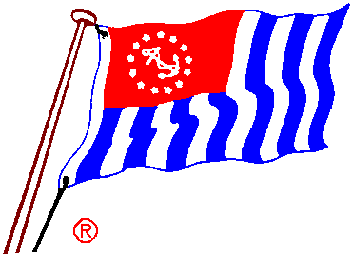
Local Squadron Charter
Be it known that upon application duly made and pursuant to resolution of the Governing Board of the United States Power Squadrons, a Local Squadron has been constituted, known as
Phoenix Power Squadron
To consist of:
Clyde H. Baker Lynn Bayless Richard N Bell William A. Bishop, Jr.
Gilbert Blanco, Jr Lawrence K. Dail Harry A. Findor George R. Gardner
Frank A. Gianelli Donald W Gillett Carl W Hebebrand John C. Jennings
Lyell E. Kerr William C Matthewson Jack B. Mathias William N. McLemore
J. Edwin Miller Thomas L. Mills Frederick W Monrad Raymond Moran
Allen G. Myers Arthur B Passey Howard Ritchart Earl L. Shaw
Fred E. Smith Henry Whelpley G. Douglass Young
And such other members of the United States Power Squadrons, as may be elected to membership therein,
This Charter is granted subject to the provisions of the Constitution and By-Laws of the United States Power Squadrons, now and hereafter in force.
In Witness Whereof, this Charter is issued under the hand of the Chief Commander and Secretary this day of 13 June 1960
(Signed by) (Signed by)
F.C McGlaughlin, JN Richard W Weber, JN
Secretary Chief Commander.
The squadron officially changed its name to Phoenix Sail and Power Squadron in 2002.
The charter remains in the custody of the Squadron Commander and is transferred to the incoming Commander at each Change of Watch.
Continued on the next page
Squadron Charter - Continued
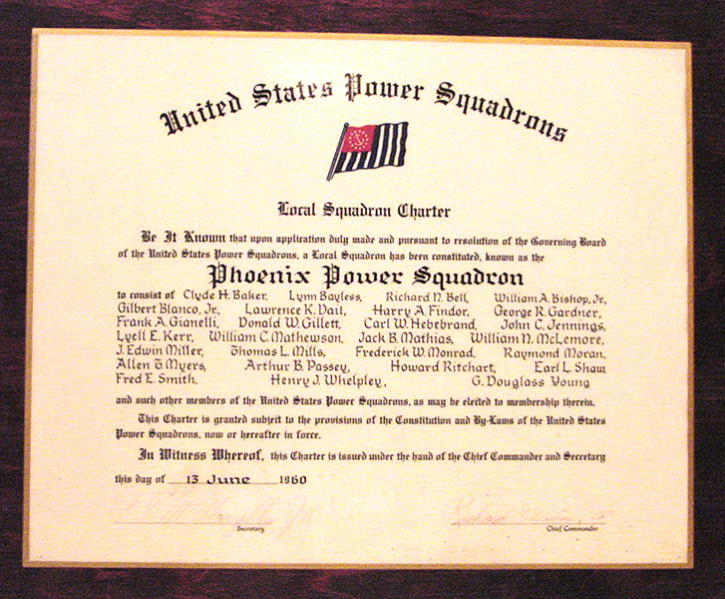
The transfer of the Squadron Charter from P/C Connie Johnson (left) to Cdr. Doug Frazier
at the 2006 Squadron Change of Watch
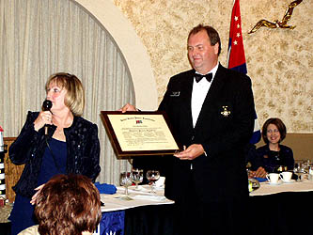
Squadron Burgee

What is the Squadron Burgee? Most members of the Phoenix Sail and Power Squadron will agree that we have one of the most attractive burgee designs anywhere including some of the most exclusive yacht clubs.

We wondered about its origin, so we called the artist who designed it nearly 50 years ago. She is Marge Young, who has been a member of USPS since 1941. She joined the Miami, FL Power Squadron while she was an artist with the Max Fleischer Studios. There she was an artist who was among those who created the original cartoon cells for popular movie cartoons of the time, including “Betty Boop”, “Popeye” and “Gulliver,” and those beloved sing-along cartoons where we followed the bouncing ball. Some can still be seen occasionally on middle-of-the-night TV, mostly by insomniacs and nursing mothers. She told us she’s now well into her 90s, and just as full of energy as ever. Until recently she was restoring original cartoon cells for collectors.

Her late husband, Douglass, was our squadron’s first commander.

Marge said she couldn’t use seagulls, lighthouses, buoys and other nautical icons because we are, after all, in the desert.

The Phoenix Power Squadron was chartered in 1960 as part of District 13. Our squadron was sponsored by the now-defunct Los Angeles Power Squadron, and we remained in D/13 until 1963 when District 28 was created. The gold border was added in 2010 to commemorate the 50th anniversary of the squadron.

We pressed her for the significance of the elements of the burgee, but she remembered only, “I just did it.” Such are the ways of great artists: That which is a marvel to us lesser beings is not big deal to this truly creative person.

The colors are traditional: red, white and blue, and were chosen for their nautical tradition. The blue segment is legendary for many burgee designs, but the red “Thunderbird” is ours alone. In fact, earlier editions of the Bos’n’s Pipe contained the slogan, “Thunderbird Squadron,” on the mailing cover, until this editor had the mailing cover redesigned. The designation was dropped for reasons now forgotten. But, we digress.

The red symbol is based on a representation of the mythical Phoenix bird of Greek and Egyptian antiquity. According to legend, only one Phoenix bird may exist at any one time, and then it lives for either 500 or 12,954 years depending on whom you ask. When its time is up, it hops on a funeral pyre and is consumed in the flames. But Shazam! A young Phoenix promptly rises from the ashes for either 500 or 12,954 more years.

Our fair central city, Phoenix, they say, was built on the traditional site of a native-American village where the vanished inhabitants cremated their dead. Hence, the name Phoenix, which is attributed to a classically educated but boozy ne’er-do-well Englishman, who legend suggests was either run out of England, or he escaped just in the nick of time.

Squadron Burgee - continued


The central symbol, the red “thunderbird” has a long history in Arizona. Thought to be a representation of the pterosaur, the thunderbird appears in ancient petroglyphs probably created by Hopi Indians, according to one source.

Fast forward to the early 1940s, and the desert became sprinkled with Army Air Corps training fields. Those north of the Salt River bore the name Thunderbird I (Glendale), Thunderbird II, (Scottsdale) and others. Training fields south of the Salt were called Falcon Fields. Phoenix, because of its unsavory reputation for “wine, women and song,” was frequently declared off limits to young student pilots by Army officials. No one remembers any complaints about singing, however.

According to Ella Clark’s Indian Legends of the Pacific, “The thunderbird is a very large bird, with feathers as long as a canoe paddle. When he flaps his wings, he makes thunder and the great winds. When he opens and shuts his eyes, he makes lightning. In stormy weather, he flies through the skies, flapping his wings and opening and closing his eyes.”

So, there you have it. Marge Young’s burgee uses as its center piece a noisy bird fitting for some Phoenix Sail and Power Squadron events.

USPS Uniforms

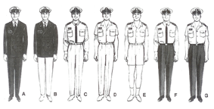
Men’s Uniforms

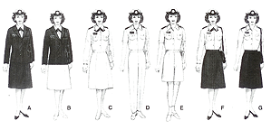
Woman’s Uniforms

The official USPS uniforms are shown above. There are a few occasions where wearing a uniform is requested, such as district and national meetings, and the Squadron Change of Watch. However, A uniform is not required for holding a USPS office or for participation in any USPS event.

The uniforms are designated by a letter A thru G. Members may wear other appropriate attire in lieu of a uniform.

Uniforms and insignia can be purchases from commercial vendors such as:

Commodore Uniform & Embroidery, Inc
335 Lower County Road
Harwich Port, MA 02646
Phone 1-800-438-8643
www.commodoreuniform.com

For more information on the subject of uniforms, attend one of the Squadron Operations Training classes.
Merit Marks
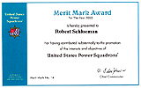
What are Merit Marks? A “merit mark” (MM) is awarded by the chief commander to a member for substantial personal effort in furthering the interest, programs and objectives of USPS, its districts and squadrons. It is a coveted award; it is by and large the only official recognition members receive for their efforts. Only one merit mark may be awarded in a year to a member, no matter how extensive the contribution. A certificate is issued (like the one above), and a special insigne may be worn on USPS uniforms.

The Squadron Merit Mark Chairman solicits information about squadron member contributions from the bridge officers and committee chairpersons for inclusion in a Merit Mark Report.

Before 15 November of each year, Squadron Commanders must submit their recommendations for merit marks through area monitors, via first class mail only (not certified or registered mail or any method which requires a signature on delivery). Merit mark recommendations postmarked after 15 November may be substantially delayed.

Any member that has earned 25 merit marks or more is exempt from national and district dues. Squadron dues are voluntary.

In recent years the squadron has held a merit mark party to honor those who have contributed their time and efforts to the squadron and thus earned their merit mark for the year.

Squadron Operating Documents
What are the Squadron Operating Documents? Operating documents are those which define how the squadron operations are performed both internally and externally. They are the Squadron Bylaws, Policies and Procedures, and Job Descriptions.
The Squadron Bylaws are a fundamental document for any organization. They set forth what we do and to some extent how we do it when it comes to managing the affairs of the squadron. The bylaws have two overlying requirements. First they are required for any Incorporated organization, and second they are required as part of the overall United States Power Squadrons®. It is the responsibility of the squadron Rules Committee to see that the bylaws are in harmony with these two requirements. Fortunately there is help from the USPS® Committee on Rules to assist with that task.
The bylaws define the structure of our squadron, what meetings we hold and when, and some basic responsibilities of the officers and committees.
The bylaws can be found on the Internet at: http://www.usps.org/lc/phoenix/bylaws.htm and upon request, from the Squadron Secretary.
The Policies and Procedures are readily amended standing rules that address circumstances that are either dynamic or unique to the squadron. They also further provide for the implementation of squadron operations that are not specifically defined by the bylaws. The Policies & Procedures are reviewed and approved at each Squadron Annual meeting.
The Policies and Procedures can be found at: http://www.usps.org/lc/phoenix/policy.htm and upon request, from the Squadron Secretary.
An Awards document was created in 2007 to retain the descriptions of the Thunderbird, Educator of the Year and John Yount Sheer Genius Awards. These awards are presented annually at the Change of Watch.
The Awards document can be found at: http://www.usps.org/lc/phoenix/awards.html and upon request, from the Squadron Secretary.
A Job Descriptions document provides the general guidelines for the tasks needed to be performed for the operation of the squadron. A glance at the 2011 Squadron Directory lists 75 jobs that the members have volunteered for, plus some that have not been filled. For a squadron this size, there are clearly enough jobs to go around.
A generic form of squadron job descriptions is available from the Internet at:
http://www.usps.org/national/ot/documents/SquadronJobGuide2009.pdf
The current version of the job descriptions that have been specifically adapted for the Phoenix Sail & Power Squadron can be found at:
http://www.phx-usps.org/OpsDocs/SquadronJobDescriptions.pdf
Detailed job descriptions of the squadron webmaster and database administrator are currently available upon request from the Squadron Secretary.
All of the above documents are also posted in the Phoenix SPS SailAngle.com filing cabinet.
Squadron Meetings
Squadron Meetings. There are five types of squadron meetings, General Membership Meetings (GMM), Annual Meeting, Change of Watch and Executive Committee meetings. All members are invited to attend each of these meetings. Guests are also welcome.
The GMMs are typically held on the third Thursday of each month, from September to June of the ensuing year, inclusive, at regularly announced meeting places. The meetings are most often held at a local area restaurant. A social hour runs from 5:30 PM to 6:30 PM, dinner at 6:30 PM, and a business meeting starting around 8:00 PM. The meeting is often concluded with a special program of general interest.
The Annual Meeting is a special GMM and occurs in the month of January, at which time an election of officers and members of elective committees, including the chairmen thereof, is held. Written notice of the annual meeting, containing a list of all active members nominated by the Nominating Committee for election to positions within this squadron, is provided to each active member via the squadron newsletter, the Bos’n’s Pipe, at least 30 days prior to such meeting.
Other special business of the annual meeting is the approval of the budget and the ratification of the Policy and Procedures.
The Change of Watch meeting typically occurs on the first Saturday of February. It is a formal dinner meeting where members wear their USPS uniforms or appropriate attire. The Change of Watch is the point in time where the outgoing officers and committee chairman are relieved of their duties and the new officers and committee members are sworn in.
Executive Committee Meetings. The Executive Committee consists of the Squadron Commander, Executive Officer, Educational Officer, Administrative Officer, Secretary, Treasurer, the most recent past commander willing and able to serve, and three active members elected from the general membership of the squadron. The committee meets monthly, typically on the second Thursday of the month, and has general charge of the policy, management and finances of this squadron. It is vested with and has legal custody of all squadron property, and will appropriate such sums as may be deemed advisable, within the limits of squadron resources, for the normal and usual operation of this squadron, including squadron, district and USPS functions.
The Executive Committee approves applications for all classes of squadron membership and conducts the normal business of the squadron between general membership meetings.
Executive Committee meetings are open to all members who may also contribute to the deliberations, however, only the members of the committee may move motions and vote on any given issue.

Squadron Awards
What are the origins of the Awards given out at Squadron meetings? The Phoenix Sail & Power Squadron has two awards that are presented each year at the Change of Watch, the Educator of the Year award, the Thunderbird award, and the John Yount Sheer Genius award .
The Educator of the Year award is defined as:
The Educator of the Year Award (as adopted 14 Jan 1999) is to be given to the Squadron member who, in the opinion of the Awards Committee, has made the greatest contribution to education in the previous calendar year, being the period from 1 January through 31 December.

The award shall be designed to include a bronze medallion which carries a raised picture of Prince Henry the Navigator.

The award shall be presented to the recipient at the annual change of watch meeting. The winner of the award should be considered a candidate for the Chapman Award at the District level.

The Educator of the Year Award Committee should be composed of three members as follows: Chairman of The Advanced Grades Committee; Chairman of the Elective Courses Committee; Chairman of the Public Boating Committee. In the event one of these is unable to serve, the Assistant Squadron Education Officer will serve in his/her place.
The Thunderbird Award is defined as:
The Thunderbird Award may be presented to an individual or group as a service award for outstanding work and service to the Squadron above and beyond the expected responsibilities of the average member or elected officer. Recipients of this award need not be Squadron members. The award shall be any suitably object engraved with the individual/s name/s and year of the award.

The Thunderbird Award Committee shall be composed of the five most recent active past commanders willing to serve with the most senior as chairman. It shall determine the selection of the award and plaque from nominations by any active member. This award, presented at the Squadron Change of Watch, may or may not be given every year.

The John Yount Sheer Genius Award is defined as:
As a boating organization and group, it is common for many unplanned scenarios to manifest themselves in a myriad of tangible and incomprehensible ways during the on the water events. It is the character and knowledge of the individual that determines how to handle the more embarrassing situations as they arise. In recognition for his many years of contributions to the squadron and in the spirit of being able to laugh at one’s self (and others) the John Yount Sheer Genius Award is created (as adopted 15 Sep 2007).

Nominations for the John Yount Sheer Genius Award shall originate from a squadron member for them self or from another member for the most amusing and/or embarrassing boating experience over the previous calendar year with the Executive Committee to determine the annual recipient. The award will be presented during the Squadron’s Change of Watch.

Submissions shall be presented to the Membership Involvement Chairman for initial review prior to and no later than the Squadron’s Annual Meeting. The top three stories will then be reviewed by the Executive Committee to determine the winner. The plaque will be returned Membership Involvement Chairman by the previous recipient prior to the Annual Meeting so that it may be presented to the next recipient.

Squadron Rendezvous and Parties
Traditional Squadron Rendezvous are those Squadron activities that are held on an annual basis. A rendezvous is an event where the members gather to enjoy the fraternal aspects of squadron membership.
Many are organized around a boating activity. Not all rendezvous require a boat or a boat ride to participate. Some can be reached via car or any form of overland transportation. Some enjoy going down to the sea in ships, for the rest of us we just like to jump in a boat and make waves.
In general each rendezvous follows the theme of the prior year event, but plans are also adjusted to meet the circumstances. It may not be the same old thing, but you can be assured they are fun and great time to visit and catch up with your friends.
The following pages list a few of the long standing rendezvous that are a basic part of the squadron schedule of boating and social activities.

Katherine Landing (Inland Rendezvous)
The Katherine Landing Rendezvous is part of the District 28 schedule of rendezvous and is typically held in April of each year. The Katherine Landing motel rates are reasonable and a local restaurant is available for meals seven days a week.
The Phoenix SPS has been host for this event for many years. The Lake Mohave PS also hosts or co-hosts the event. Other locations for the event have been at Black Meadow on the Colorado River, but the accommodations and location of Katherine Landing is convenient for all the squadrons of District 28 to attend.
The basic format is for members to trailer their boats to Katherine Landing, located at the south end of Lake Mohave near the cities of Bullhead City, AZ and Laughlin, NV. The location has a good motel and marina, plus campgrounds for everything from bare ground camping to motor homes and trailers. The casinos of Laughlin also offer alternate lodging and entertainment.
Activities begin on Friday with a happy hour on the lawn in front of the motel. That evening many make the short trip to Laughlin for dinner at one of the casinos.
Saturday is filled with both on the water and shore events. The on the water events begin with a poker run, a mid day raftup or beaching the boats in a sandy cove, and an afternoon of exploring Lake Mohave. If two or more sail boats attend you can bet there will be a race. Saturday evening is spent at the campground ramada for a dinner cookout and evening entertainment.
Sunday is reserved for a predicted log race if interest prevails.
Poker Run
What is the Katherine Landing Poker Run? This is a chance to use your boating and map reading skills to find an illusive orange bucket filled with envelopes.
Lake Mohave is a lake lined with many small coves that each bears a name. The poker run organizer will place five decks of cards, one card at a time, in sealed envelopes. These envelopes are then distributed equally into five bright orange plastic buckets. Using a map of the lake, clues are written that describe the location of the coves where the buckets will be placed. Each boat will receive a map of the lake and a copy of the location clues.
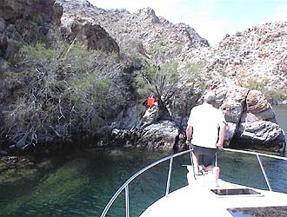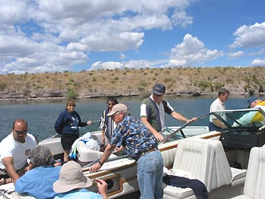
Players may purchase one or more hands of five cards each, one card for each hand to be retrieved from each bucket. The typical game charge is $1.00 per card, or $5.00 per hand. The poker run is limited to 52 hands.
This is not a race or timed event. Players decode the clues and then set out on the lake to recover their cards from the five buckets. The envelopes are not to be opened until the hands are played at the evening cookout.
Typically the poker run is held on Saturday morning with the group of boats rendezvousing over the noon hour for a little relaxation, snacks, and conversations. Those without boats can usually join the game aboard one of the boats participating.
Several levels of cash and merchandize prizes are awarded based on the best five card poker hand.
For photos and descriptions of the most recent Phoenix SPS hosted D/28 Inland Rendezvous at Katherine Landing visit:
http://www.phoenix-usps.org/inrendv.htm

Past Commander’s BBQ
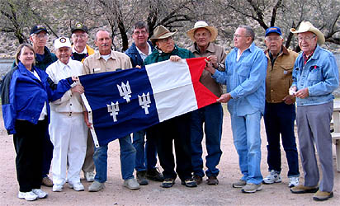
Some of the Phoenix SPS Past Commanders
The Past Commander’s BBQ is not a time when the squadron past commanders are barbequed, but then again they do not get off easy either. This event is open to all squadron members, children, guests, and the past commanders do all the work. They cook the food, serve, and wash the dishes. The menu consists of barbequed beef and chicken, coleslaw, beans, garlic bread, plus ice cream and pie for desert. Plates and utensils are supplied. If you would like to see the recipe that the past commanders use for the BBQ visit: www.phoenix-usps.org/recipe.htm#anchor5586 – mmm good.
The BBQ is held on a Saturday afternoon in March of each year, and in recent years, at the Canyon Lake campground. This site is well suited because of its ramada picnic area and space for RVs with/without hookups. Many bring their motor homes or trailers and stay overnight from Thursday through Sunday. Some brave souls even trailer their boats up the winding paved road to the lake.
The activities generally start around 3 PM with a social hour either at the ramada or around the RVs. Those with boats will take those without for a tour of the lake. Dinner is served at 4 PM and is followed by a brief general membership meeting and cash raffle.
The Canyon Lake campground has a fee controlled access. Depending on the flexibility of the campground management, the Squadron is able to negotiate a reduced fee for this group function. Proceeds from the dinner ($8 per person, children under 12 free), less expenses are donated to the squadron operating funds.
So come and enjoy a day at the lake, good food, and good friends. Typical attendance ranges from 40 to 60 people, and nobody goes hungry.

The OFC Cruise

BÃTA MÕR  (Gaelic for "Nice Boat)"  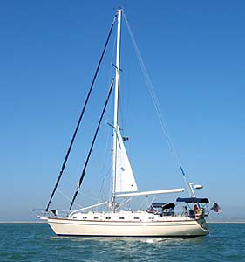  Tim Harrington - Skipper | WIND TREE  (This one is pretty nice also)  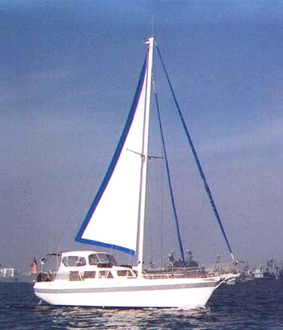  Frank Fitzgerald - Skipper
The OFC Cruise, otherwise known in polite circles as a cruise for the chronological challenged, is a sail cruise in the waters of the Pacific off southern California. The cruises range from 1 to 2 weeks and may visit ports of call from Baja, Mexico to the Channel Islands. An often repeated cruise is a passage to Catalina Island with moorings in Avalon, the Isthmus and its adjoining coves, or Cat Harbor.
Members of the squadron act as crew for those that have sail boats in San Diego. Every trip is a new adventure. The sea life in the waters off southern California is something you can spend hours watching. Everything from whales, sharks, huge pods of porpoises that seem to take delight in swimming along side riding the bow wave, sea lions, and sea birds inhabit these waters.
These cruises are not typically true sailing trips as the winds along the coast seldom are favorable to power by sail only. Keeping a boat on course in a rolling sea is and experience that all should find interesting and challenging. When winds are favorable, the sound of just the wind and waves is unforgettable.
A challenge to the sailor is the navigating out of sight of land and interacting with the commercial and naval vessels that frequent the US waters. A passage from the mainland to Catalina takes one across the busy shipping lanes in and out of the port of Los Angles.
This cruise is held typically in the first part of June before the schools let out in California. The timing is selected to achieve the best possibilities for obtaining moorings at Catalina.
For information about the most recent OFC visit: www.phoenix-usps.org/ofc.htm

Cholla Bay Fish Fry
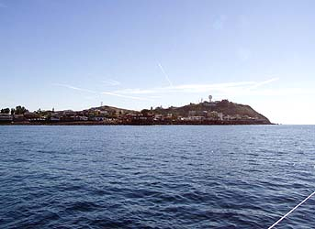  Puerto Peñasco | 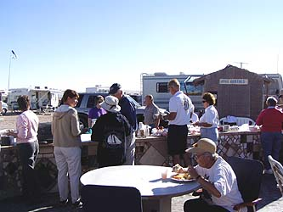  Sunday Breakfast

Nobody remembers when it started, but it has been a part of the social scene for most of the existence of the Phoenix Sail and Power Squadron. It is the Cholla Bay, Mexico, Fish Fry, presided over at various times by P/C Fred Drawert, AP; P/C Les Ormsby, JN; Jose Pallavicini, S; and P/D/C Paul Schoonover, SN.

In recent years, variations in the arrangements for the event have varied, but in 2006, the program settled into the comfortable program of the meal prepared by members of the squadron.

The fish fry’s agenda has always been heavy on relaxation. In recent years, the formal festivities have begun on Friday evening with a potluck reception featuring tequila sunrise adult beverages, and homemade clam chowder. The venue was at the home of Janet and Jose Pallavicini overlooking Cholla Bay at Puerto Peñasco, Mexico. In 2006, the outing was blessed by a full moon which meant the tidal change in the bay had the potential reach 24 feet.

Saturday was characterized by a pot pourri of activities, including watching the tide come in and go out, part of the aforementioned relaxation. Saturday night was the fish fry at the home of Paul and Grace Schoonover, also on Cholla Bay. Although the menu occasionally varies, it is usually fresh fish, potato salad, cole slaw, biscuits and a splendid desert. On rare occasions, there was a remnant of tequila sunrise left over from the evening before to share before dinner.

Following dinner there can be a program. This year’s featured a rather bawdy version of “Little Red Riding Hood,” which was captured on videotape for a later showing. It will not be lost to obscurity. This is followed by traditional bingo with fabulous prizes. Bingo games have been held at Fred and Josephine Drawert’s home and that of Les and Mary Ormsby. All of the locations are within an easy walk. Many participants stay at nearby RV parks.

Sunday morning the venue shifts to one of the RV parks on Sandy Beach, which overlooks the Sea of Cortez. There breakfast is served to prepare the merry band for the return to Arizona and California, as members of other squadrons in the district are invited to participate each year.

The turnout usually is between 50 and 70 people. The number seems to grow as those who attend vow never to miss a future version the fabled Cholla Bay Fish Fry.
www.phoenix-usps.org /fishfry.htm

Christmas Party

 | 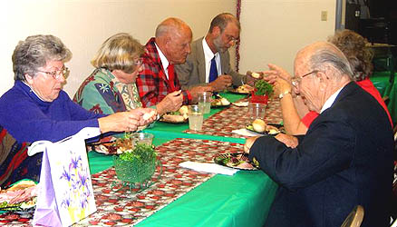
The annual Christmas party is purely a social function and no squadron business is conducted. It is just a time to get together before the holidays to share some good food, beverage and conversation with one another.
The location varies from year to year, but is frequently hosted at one of our member homes or businesses. In recent years the party has been held at Willie Burgeson’s home in Chandler, Paul Schooover’s home in Carefree, Fred Drawert’s home in north Scottsdale and Cave Creek, and Bill and Connie Johnson’s business facilities in Glendale.
The theme of the party is Christmas and is a catered event. We also bring small gifts to exchange (with the help of Santa and his Elves) and on occasion, gifts for needy children or dry staple goods for the homeless.
The party plans are publish in the Bos’n’s Pipe and can also be found at:
www.phoenix-usps.org/xmas.htm

Area Lakes Rendezvous
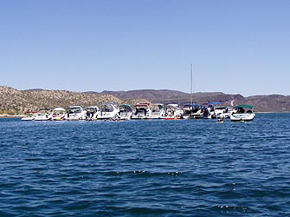
A Lake Pleasant Raft-up
Although surrounded by desert, the Phoenix Sail and Power Squadron offer great ways to help satisfy a desire for recreational sail and power boating. The man made reservoirs in the metropolitan Phoenix area of Lake Roosevelt, Apache Lake, Canyon Lake, Saguaro Lake, Bartlett Lake, and Lake Pleasant are within in easy driving distance. The squadron also makes annual trips to Lake Powell and Lake Mohave each year.
Lake Pleasant has frequent rendezvous, raft-ups, and theme events, such as a snow cruise, birthday cruise, soak-and-sweat raft-ups, and Halloween parties. The Past Commander’s BBQ is most often held at Canyon Lake or Lake Pleasant, and an annual trip to Apache Lake or Lake Roosevelt is scheduled for those that seek and adventure in mountain road driving and an early spring opportunity to get the boat wet. Bartlett Lake has been the site of the annual Turkey fry.
An annual rendezvous with the other squadrons of District 28 is held at Lake Mohave each spring (April) offering a chance to not only do a poker run, predicted log race, but to also visit the casinos in nearby Laughlin for fine dining and financial adventures.
Currently the squadron has two rendezvous at Lake Powell., one in June and the other in October. The variable levels of that lake provide many opportunities to view the canyons with different exposures.
The typical raft-ups and rendezvous generally involve get together to share food and drink.

Civic Service
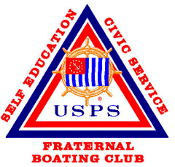
Squadron Civic Service consists of several activities. They include the Public Boating Safety Classes, Environmental Cleanups, Vessel Safety Check, Boat Show, and the Arizona Safe Boating Celebration. All are designed to enhance public awareness of boating safety or contribute to a local or national need.
The following pages illustrate what is involved. It takes a lot of people to carry on these activities and every member is encouraged to pitch in and lend a hand. As we “show the flag” for these events the public will be become more aware of just what is the Phoenix Sail & Power Squadron – a group of dedicated individuals working for the common good.
Arizona Safe Boating Council
What is the Arizona Safe Boating Council (ASBC)? The ASBC is an informal coalition of the Phoenix Sail & Power Squadron, Arizona Game & Fish Department (G&F), and the US Coast Guard Auxiliary Arizona Flotillas (USCGAux).
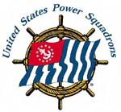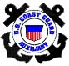
In the late 1990s it became evident that the three major safe boating organizations in Arizona needed to come together and formulate a working relationship to further promote boating safety. By working together it was felt that a combined voice would be better heard.
Initial efforts were to form an organization along the lines of the National Safe Boating Council with a paid staff and a level of corporate and private membership. A set of bylaws was developed and circulated among the founding member organizations. Major problems developed with the association of the G&F in a nonprofit entity – it was not possible. At that point the aspirations of the group was reduced to an “informal association”. There are no officers, staff, or formal written policies of association, just a “gentleman’s agreement” to work together whenever and wherever to promote boating safety.
A formal Statement of Agreement (SOA) exists between USPS and the Arizona G&F. A similar agreement exists between the USCGAux and the Arizona G&F. These SOAs insure that the public safe boating courses are high caliber and approved by the National Association of Boating Law Administrators (NASBLA). USPS and USCGAux curriculums also include components of the Arizona Boating Regulations.
Manifestations of the ASBC have been the combined presence at the annual Boat Show and a set of Guidelines for members manning the booths, the Arizona Safe Boating Celebration, and the ASBC combined public safe boating course listings. These mutual activities have provided an opportunity to develop personal contacts and respect.
Dedicated Internet websites maintained by the Phoenix SPS are:
Arizona Safe Boating Celebration: www.azsafeboating.org
Arizona Boating Class Schedules: www.azsafeboating.org/asbc
Arizona Safe Boating Celebration
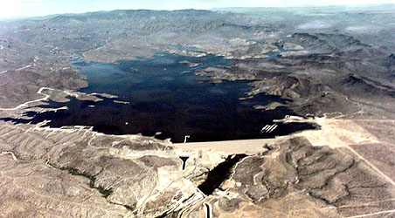
What is the Arizona Safe Boating Celebration? In 2004, then Squadron Executive Officer, Connie Johnson, organized what became known as the Arizona Safe Boating Celebration. It was her vision as way to involve the member organizations of the Arizona Safe Boating Council in a demonstration of the importance of boating safety to the boating public beyond that of the annual boat show.
Numerous planning meetings were held at the Lake Pleasant Park headquarters building and involved people from the Phoenix SPS, AZ Game & Fish, USCG Auxiliary, Maricopa Parks Department, and the Peoria Fire Department. The inaugural event was held 22 May 2004 at the ten lane ramp area of Lake Pleasant and involved numerous booths, min-classes, prize drawings, and invited guest speakers. Bill and Connie Johnson plus Doug and Nancy Frazier also contributed financially to the event
Although marginally successful at first, due in part to its location out of the normal traffic flow to and from the lake, plans have been refined for the Celebration the following years, and is now centered on the “make ready” area of the launch ramp. Photo story for all the past Celebrations and this year’s event can be found at:
www.azsafeboating.org
Cooperative Charting
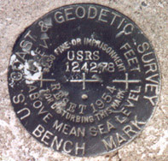
Cooperative Charting is the recovery and reporting of the condition of geodetic marks, nautical and aeronautical chart features, plus tide and current measurements. The Phoenix Sail & Power Squadron cooperative charting activities are typically limited to recovery of geodetic marks.
Geodetic marks are reference points established on the surface of the earth by state, local, and federal agencies. The geographic location of these reference points has been established with extreme accuracy, frequently to a fraction of an inch or so. Geodetic marks are used as starting points for land survey, map making, engineering, construction, environmental measurements and geological studies. Roughly 1 million of these marks have been selected by the National Geodetic Survey Division (NGSD) to be included in the National Spatial Reference System (NSRS), sometimes called the "net". Maintenance and preservation of these marks is of utmost importance to users of the net and to NGSD, recognizing that many valuable geodetic marks are destroyed by construction, new roads, erosion, or for other causes. Our job is to locate each of these marks and report their condition together with any change in the directions needed to locate them.
Generally, the mark (or "station", as it is sometimes called) can be a water tower, a building, a monument, or even a nautical aid to navigation. Normally, however, the mark is a round bronze disc, roughly 3 inches in diameter, firmly embedded in a square, rectangular, or cylindrical concrete post usually at ground level or several inches below the surface, though it may be above ground level as well. Sometimes the mark is set directly in bedrock, and frequently it is found in the form of a rod enclosed in a plastic pipe.
Geodetic stations are generally found along roads, highways, property lines, etc., though many times they are found on high ground such as hills and mountain tops. Each station has a unique designation, generally having local significance to near-by residents, places, or business establishments. You need to know the names of each station along a specific search route in order to locate the corresponding description provided by NGS. Descriptions contain directions needed to locate each station and may include distances along roads or from local landmarks or reference points, nearby houses, intersections, trees, culverts, bridges, telephone or power poles, fences, gates, etc.
Geodetic mark recovery is a valuable service to NGSD, participation is interesting, challenging, personally satisfying and always brings a sense of accomplishment.
In 2007 the NGS dropped the Geodetic Mark recovery program. The only segment of Cooperative Charting now available to USPS members is the Nautical Chart program. Being a land locked squadron with no coastal facilities or ports; the Phoenix SPS is no longer involved.

Vessel Safety Check
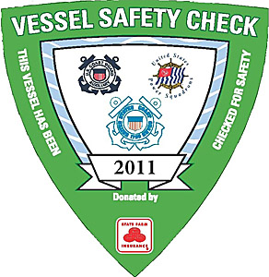
A Vessel Safety Check is a courtesy examination of a boat (Vessel) to verify the presence and condition of certain Safety Equipment required by State and the Federal regulations. The Vessel Examiner is a trained specialist and is a member or the US Power Squadrons or the US Coast Guard Auxiliary. They will also make certain recommendations and discuss certain safety issues that will make safer boaters.
This is not boarding or a law enforcement issue. No citations will be given as a result of this encounter. They supply the boater with a copy of an evaluation so that they may follow the suggestions given. Vessels that pass will be able to display our distinctive VSC decal. This does not exempt them from law enforcement boarding, but they can be prepared to make this a positive encounter
To become a qualified Vessel Safety Examiner one needs to complete a short course of study and an exam. Both these can be accomplished online. Full certification for an examiner comes after the completion of 5 supervised vessel exams. Each examiner retains his/her certification by completing 5 or more vessel exams each calendar year.
Follow the progress of the squadron vessel safety examiners by viewing:
http://www.usps.org/lc/phoenix/phxvsc.htm

Public Safe Boating Classes
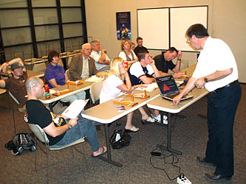
Public Safe Boating Classes are offered to the public numerous times during the year at sites in Scottsdale, Tempe, and Peoria. There are a number of courses to choose from and all are approved by the National Association of State Boating Law Administrators (NASBLA). The most frequent course being offered is the Boat Smart Course.
The Squadron Boating Course ^{(SM)}, and America's Boating Course® (ABC) are designed to familiarized the student with the fundamentals of safe boating and qualifies for certification in most states that require boating education before operating a watercraft (not currently an Arizona requirement). The Squadron Boating Course is structured for one night a week, two hours each session, and is completed in eight weeks. America's Boating Course(s) is one night a week, two hours each session, for four weeks. Admission is free. Although not required, course study guides and supporting materials are available for minimal costs.
The current class schedules can be found at: www.phoenix-usps.org/boatcr.htm
For an annual list of classes in District 28 visit: www.usps.org/lc/d28/d28BoatingClasses.html
If you have time and would like to help with these classes, be it proctoring or as an instructor, contact the Squadron Public Boating Course Chairman. Classes are currently being run on Wednesday nights.
Squadron Website
® | Phoenix Sail and Power Squadron  A Unit of United States Power Squadrons® - District 28  Sail and Power Boating    Boating is fun..We'll show you how | 
The Squadron Website is hosted by the USPS server at no charge to the squadron. Its size is limited to 30 Mbytes and is currently just below that limit. Its URLs are: www.phoenix-usps.org or www.usps.org/localusps/phoenix or www.usps.org/lc/phoenix.
The fundamental design of the website is to present an “open house” of the Phoenix SPS. It contains photo stories, articles, reports, and documents depicting the activities of the squadron. It is maintained by the squadron webmaster and is updated frequently, sometimes on a hourly basis.
The site consists of 41 pages, some of which have additional supporting pages as well. Navigating to these pages is done via clicking on any of the links in the table below. That table is located near the bottom of each page and is repeated on every page, i.e., your can get to anywhere from everywhere.
Site Map
Boating Courses | Squadron Officers | Bos'n's Pipe | Calendar of Events | Lake Pleasant
Seminars & BOC | Commander's Message | Tribal Knowledge | Potlucks and Parties | Lake Powell
Learning Guides | Officer Reports | Galley Gourmet | Change of Watch | OFC Sail Cruise
Advanced Courses | Environmental | Recipe Archive | Cholla Bay Fish Fry | Power Cruise
Elective Courses | Vessel Safety Check | Ship's Store | Colorado River | San Diego Raftup
Regional Boating | Boating Links | Home Page | Lynx Lake | Salt/Verde Lakes
Boating Courses, Learning Guides, Advanced and Elective Courses provide class schedules and content of the squadron education programs.
The Regional Boating page has current information about local lakes. Vessel Safety Check page has reports of the current squadron standings with those programs and are updated weekly.
The photos of the current Bridge are located on the Squadron Officers page. The Commander’s Message and Officers Reports pages are updated monthly. The Bos’n’s Pipe, Tribal Knowledge, Galley Gourmet, and Recipe Archive are updated monthly or more frequently if conditions warrant.
The link to the Calendar of Events is updated as often as needed. The various squadron activities links provide information about upcoming events and descriptions and photos from their most recent occurrence. They provide planning information prior to the events as well. The Lake Powell page is updated bi-weekly for the Lake water level and inflow conditions.
The Site Map has a listing of all the pages on the site along with their latest revision date. A link to the squadron operating documents section is found only on that page.
All members are encouraged to contribute to the website. If you had fun at any activity and some photos to go with it, pass them along to the webmaster so the website can tell “the rest of the story”.
The website consistently receives the USPS Website Award.
Squadron Electronic Mailing List/SailAngle.com
The squadron Electronic Mailing List (sometimes referred to as a reflector) was discontinued in 2009. It was replaced by a private system hosted by SailAngle.com. As a private system the user must be a current member of the USPS to use the system.
The system functions a communications tool much the same as an electronic mailing list plus a number of additional features. It is an opt-in system. The basic structure of the systems has the following functions:

Home
Messages
Forum
Photos
Calendar
File Cabinet
Members
Sub Groups
Join Requests
Help

The messaging system has two types, group and forum. The group messages are sent to all members of that group and are moderated, whereas forum messages are structured by subject and any member .

Any member may upload their photos to the Photo section. The file cabinet us used to provide access to a number of operational documents.

The Members option allows a view of the members on the list. Sub Groups are dedicated to use by squadron committees.

A feature of SailAngle.com groups is that any member of USPS may ask to be included in any of the squadrons, districts, and national committees groups.

The Help function on the national group provides access to a number of tutorials that explain the operation of the USPS SailAngle.com system.
Members that join the USPS SailAngle.com group are automatically added to the national, district and home squadron groups. One login and password is used for all groups. The login is the user certificate number and the password is either their zip code or user defined personal identification (PIN). Users need only include such personal information that they feel comfortable with when completing their profile.
Squadron Online Roster
An Online Roster is maintained as a part of the squadron website. It is login and password protected. Access is further limited to only members of the Phoenix SPS. The URL for the online roster is:
www.phoenix-usps.org/roster
Your personal information is login/password protected is the same as is used for any “USPS member only” website, i.e., the login is your certificate number and the password is your 5 digit zip code. Remember to use capital letters for the login and do not drop any leading zeros. You should also consider clicking on the “remember” box the first time you log in. That will save you the effort of having to enter it again for a year (provided you have enabled “cookies” in your computer).
The roster contains several elements. There is a listing of all the squadron members and affiliates with basic contact information, a squadron organization chart, squadron fleet, and squadron statistics.
From time to time it becomes necessary to change your contact information, be it city, state, street address, email address, and/or boat information. That can be easily done by opening the roster online and edit the data that needs to be changed. That is done by clicking on the user name and entering the new information in the text boxes that apply. Clicking on “Update” will send that new information to the Squadron Database Manager who will do the following:
1) Update the squadron database and send the information to USPS headquarters. This insures that your copy of the ENSIGN will arrive on time and all further correspondence from USPS will be directed to a new address as appropriate.
2) If an email address has changed, forward that to the Mailing List Administrator for update to the subscriber list.
3) Forward the new information to the Bos’n’s Pipe publisher and the Squadron Directory chairman.
The online roster reflects the latest information we have about our members and supports the Squadron Directory between its publishing times.
New members are added to the online directory as soon as their membership is approved by the Squadron Executive Committee. Their record will be identified as “New Member” until such time that their application has been processed by USPS headquarters and a Certificate number assigned.

District 28
What is a District? This question comes up more than we wish, but never the less deserves an explanation. The USPS is a very large organization with some 50,000 members. Each has a voice that needs to be heard. If we all spoke up all at once that would just produce a lot of noise. There has to be a better way, and fortunately there is.
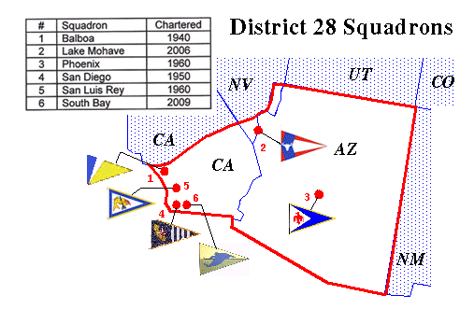
The building blocks of the USPS are its squadrons, all 448 of them. Within our squadrons we discuss those things that we think will improve the organization and promote progress. We try things that work and some that do not. Every once in a while a real good workable idea comes along that needs to be shared. That is where the District comes in as all squadron initiatives must pass through the District to reach the National level. The voice becomes that of all the squadrons in the District.
The purpose of the District is to discuss the merits of any squadron initiative, and if agreeable to the rest of the squadrons in the district, the initiative is forwarded on to the national level as a resolution. The resolution is then assigned to an appropriate national department and reported at the next Governing Board meeting with a proposed implementation and recommendation to approve or reject. The Governing Board votes and if approved the resolution is implemented for all of USPS.
The District is also the meeting forum where the squadrons discuss their accomplishments and shortfalls. A group of experienced District Officers and Committee members serve as a conduit to forward information from national to the squadrons and vice versa. They are also available to assist with any issues.
The District is also an opportunity to meet new friends in other nearby squadrons. We all have a common love and appreciation of boating, but you find out we also have a lot more in common than you think.

District 28 - Continued

USPS District 28, for which the Phoenix Sail & Power Squadron is a part of, generally holds four meetings a year. Special meetings can be called by the District Commander if circumstances warrant.
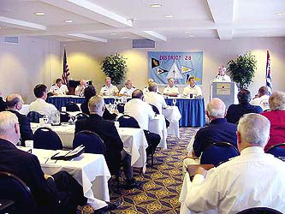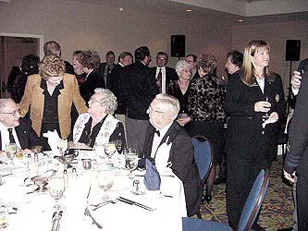
There are two types of meetings, a Conference and a Council. The District Conferences are held in the spring, usually in March, and in the fall, usually in October. The Council meetings are in between the Conferences usually in June and December. The names of the meetings take on the season of the year such as:
Spring Conference (District Change of Watch and Awards)
Summer Council
Fall Conference (Educational Awards)
Winter Council
The district meetings provide an opportunity for the squadron leadership to meet and discuss issues of common interest. Any matter that needs to be forwarded to the national level are dealt with at a Conference. A representative of the USPS Chief Commander attends all District Conference meetings.
The Council meetings are typically a one day affair with no formal social activity. On the other hand, the Conference usually involves a Friday evening social time, a Saturday meeting, and a Saturday evening banquet. A Saturday spouse activity is common at all District Conferences.
Currently the district Council meetings are held at facilities in San Diego, Chula Vista, or Oceanside CA. The Conference meetings rotate through the cities of the squadrons on a pre arranged schedule and are “hosted” by the squadron in that area.
All members are encouraged to attend the District meetings and participate in the discussions.
The Council is composed of the District Bridge Officers, the immediate Past District Commander willing to serve, the chairmen of the General and Standing committees, and Squadron Commanders. These are members that may offer motions and vote.
The Conference is composed of the Council, the Past District Commanders of the district who are active members of the district squadrons, and squadron delegates (1 per every 25 active squadron members or major fraction thereof). These are the members that may offer motions and vote.

District 28 Rendezvous
District Rendezvous are those that are officially recognized by the District and included in calendar of events for the year
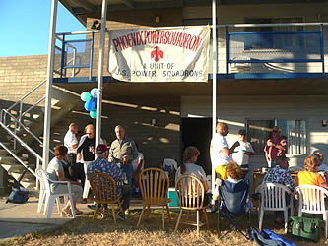
The geographical diversity of the district dictates that these rendezvous be either inland or coastal. Over the last several years the Phoenix Sail & Power Squadron and Lake Mohave Power Squadron have hosted the inland rendezvous at Katherine Landing, AZ. It is usually held on a weekend in April or early May.
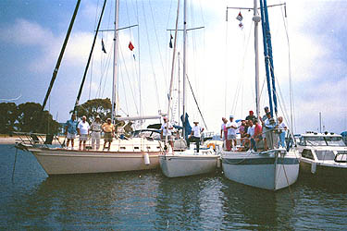
The coastal rendezvous is an offshoot of another Phoenix SPS event, the Glorietta Bay Raftup that was our excuse to get out the heat of the desert and over to the cool Pacific waters. That event is now hosted by the San Diego Sail & Power Squadron and may involve an overnight raftup in Glorietta Bay, La Plya Cove or Mission Bay. It is usually held on a weekend in July or August.
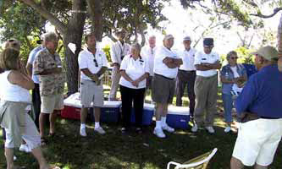
Although not an official district rendezvous, many District 28 members also attend the San Luis Rey Sail & Power Squadron BBQ in Oceanside, CA. Some come by car and others by boat. That event is typically held on the first weekend following the 4th of July.
District 28 Awards

District 28 Awards include the Star Award and the Attendance Award (presented at the Spring Conference), and the Prince Henry The Navigator Award, the Donald Schokey Award, the Ernie Casale Engine Maintenance Trophy (presented at the Fall Conference). The status of the squadron educational award efforts is posted on the District 28 and updated at the end of the month for the award year.

Did you know that the District 28 Star Award is a program to recognize the achievements of the squadrons in USPS District 28? It was begun back in 1994 upon the initiative of then District 28 Commander, Joe Komlance and was modeled after a similar program used in District 10. It is a contest where there are only winners and awards are given at each District Spring Conference for one, two or three Stars. All squadrons can and have received the highest recognition of three Stars.
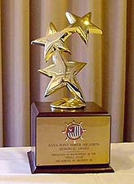
How does it work? It measures the accomplishments of each squadron bridge department, commander, executive, educational, administrative, secretary, and treasurer for the period between 1 February and 31 January of each year inclusive of the beginning and terminating dates. Star points are achieved throughout the year by a set of tasks accomplished by each squadron department and the squadron overall. Each of the squadron commanders has a score sheet by which they may monitor the progress of the squadron throughout the year. By monitoring that score sheet the squadron can determine their progress and where further emphasis need be applied. Think of it as a report card that shows strengths and/or weaknesses.
A complete description of the Star Program can be found on the Internet by visiting the Deeds of Gift page of USPS District 28 website at: http://www.usps.org/lc/d28/member/deeds_of_gift.html. Take a look and judge for yourself how the squadron is doing then pitch in and join the fun of achieving that coveted Three Star Award each year.
Ernie Casale Engine Maintenance Trophy
The Ernie Casale Engine Maintenance Trophy is defined by the District 28 Deeds of Gift as:

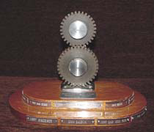

In the interest of promoting fellowship between the members of USPS District 28, and of developing interest in Engine Maintenance, Huntington Beach Power Squadron took pleasure in donating the first perpetual trophy for Elective Courses in District 28.

This trophy shall be awarded annually at the Spring Conference to the District 28 Squadron who has the best record of members who passed "Engine Maintenance" on a % of the Squadron members during the past educational year, expressed as a percentage of the total eligible squadron membership. These statistics will be based upon USPS national educational report as of the end of the educational year.
A complete description of the Ernie Casale Engine Maintenance Trophy can be found on the Internet by visiting the Deeds of Gift page of USPS District 28 website at:
http://www.usps.org/lc/d28/member/deeds_of_gift.html.

Prince Henry the Navigator Award



The Prince Henry the Navigator Award was presented by the Portuguese Government, represented by Commander Jose' Cabral, to District 28 United States Power Squadrons®, October 19, 1969 at the Fall Conference in Phoenix, Arizona.

This trophy is to be awarded annually at the Fall Conference of District 28 of the United States Power Squadrons® to the Squadron in District 28 having the highest score expressed as a percentage determined by dividing an ACHIEVEMENT SCORE by an OPPORTUNITY SCORE computed as follows:

The ACHIEVEMENT SCORE for each Squadron will be based on the Advanced Grades awards made to active and family members, and certificate holders, of that Squadron during the period commencing on 1 July and ending on 30 June of the fiscal year for which the award is to be made (Award Period).

The OPPORTUNITY SCORE for each Squadron will be computed using "Educational Department Statistics" of that Squadron for the Award Period mailed from USPS headquarters.

A complete description of the Prince Henry The Navigator Award can be found on the Internet by visiting the Deeds of Gift page of USPS District 28 website at:
http://www.usps.org/lc/d28/member/deeds_of_gift.html.

Donald L. Shockey Memorial Award

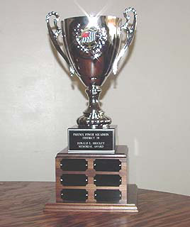

This trophy is awarded annually at the Fall Conference of District 28, of the United States Power Squadrons®, on a rotational basis to the Squadron in District 28 having the highest score determined by dividing an Achievement Score by an Opportunity Score, expressed as a percentage, computed below.

The Achievement Score for each Squadron will be the total number of Elective Courses Awards made to the members of that Squadron between 1 September of the year of the award, and 1 September of the prior year, using the notification date shown on the Award Notice mailed from USPS headquarters.

The Opportunity Score for each Squadron will be computed using "Educational Department Statistics" dated 31 July of the year immediately preceding the year in which the trophy is awarded, and will equal the difference between the product of the number Elective Courses then available (presently four) multiplied by the total member count of the Squadron, and the total of the counts of all the Elective Course awards then having been made to members of the Squadron.

A complete description of the Donald L. Shockey Memorial Award can be found on the Internet by visiting the Deeds of Gift page of USPS District 28 website at:

http://www.usps.org/lc/d28/member/deeds_of_gift.html
Teaching Aids Trophy

(Trophy currently missing)

P/D/C Malcolm M. Coston, SN presented a deed with no qualification the "TEACHING AIDS TROPHY" to District 28 of the United States Power Squadrons®. The trophy, which consists of a suitably en-plaqued ship' wheel, and became the property of the District and will be awarded at the Fall Conference of D/28 unless no Fall Conference is scheduled. In the event of no scheduled Fall Conference, the award shall be made at the Spring Conference immediately following the date at which a Fall Conference would normally meet.

The award is made for proficiency in design, simplicity of creation, ease of transportation and effectiveness in communication of the teaching point for which the aid has been designed.

All Squadrons are notified by the Education Department of District 28, specifically the District Educational Officer, of the date of award and the squadrons will be actively solicited to provide one or more Teaching Aids for judgment on the date of the award.

The most successful Teaching Aid in meeting the above requirements will be chosen by a committee of three (3) qualified members. The Committee in turn shall be selected by the District Educational Officer and the District Commander acting together in private. The Members of the Committee will not be divulged to the Members and Delegates to the Fall Conference.

A complete description of the Teaching Aids Trophy can be found on the Internet by visiting the Deeds of Gift page of USPS District 28 website at:

http://www.usps.org/lc/d28/member/deeds_of_gift.html

District 28 Attendance Trophy

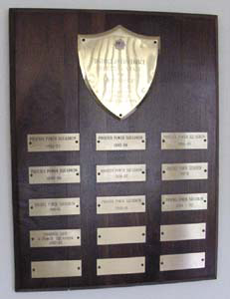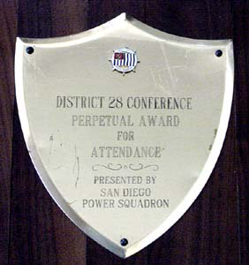

From District 28 Policies and Procedures, Section 3, paragraph 7:

For the award of the District Attendance Trophy, attendance at meetings will receive the following points:

A. Meetings as specified below:

Conference - ONE (1) point for each Member in attendance.
Council - THREE (3) points for each Member in attendance.

B. Mileage Factor - After a Squadron's total points have been computed, that number shall be multiplied by an appropriate multiplier from the table below:

 | PHX | SD | BAL | SLR | LM | SB
PHX | 1.0 | 1.4 | 1.4 | 1.4 | 1.3 | 1.4
SD | 1.4 | 1.0 | 1.1 | 1.0 | 1.4 | 1.1
BAL | 1.4 | 1.1 | 1.0 | 1.0 | 1.3 | 1.3
SLR | 1.4 | 1.0 | 1.0 | 1.0 | 1.4 | 1.2
LM | 1.3 | 1.4 | 1.3 | 1.4 | 1.0 | 1.4
SB | 1.4 | 1.1 | 1.2 | 1.2 | 1.4 | 1.0

The total points for each Squadron will be summed for the year preceding a Spring Conference and the award will be made at the Spring Conference to the Squadron with the greatest total.

A complete description of the District Attendance Trophy can be found on the Internet by visiting the Policies and Procedures page of USPS District 28 website at:

http://www.usps.org/localusps/d28/member/d28policies.html

District 28 Website
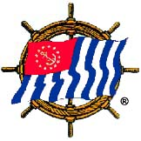 | UNITED STATES POWER SQUADRONS ®  Sail and Power Boating  Boating is fun..We'll show you how  DISTRICT 28
    Balboa |   Lake  Mohave |   Phoenix | 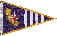  San Diego |   San Luis  Rey |   South Bay

The District Website is hosted by the USPS server at no charge to the district. Its size is limited to 10 Mbytes and is currently near that limit. Its URLs are: www.usps.org/localusps/d28 or www.usps.org/lc/d28.
The underlying principle for the design of the website is to provide an information and resource website for district operations and activities. It contains photo stories, articles, reports, and documents depicting the activities of the district. It is maintained by the district webmaster and is updated frequently.
The site consists of 18 pages, some of which have additional supporting pages as well. Navigating to these pages is done via clicking on any of the links in the table below. That table is located near the bottom of each page and is repeated on every page, i.e., your can get to anywhere from everywhere

Links to what we do and how we do it
District Bridge | District Organization | District Committees | District Calendar | District Documents
District Activities | District Publication | Commander's Message | Squadron Organizations | Site Map
Membership Report | Educational Report | Vessel Safety Check Report | Cooperative Charting | More Boating Links
 | Safe Boating Classes | Cruises/Rendezvous |  | Home
The makeup of the District is provided by the District Bridge, District Organization, District Committees pages. The District Calendar lists the activities for the watch year.
The District Activities page is a record of the district event for the year. Links to the Call to Meetings, agendas and travel issues are posted on that page. The bi-annual district publication, the Lead Line, is available via the District Publication page.
The Squadron Organizations page list members of many of the squadron officers and committee chairmen within the district. The Cruise/Rendezvous lists all the events for the district and its squadrons. The Safe Boating page gives the annual schedule of public safe boating classes presented by the squadrons. Reports included on the website are the Membership and Educational reports (updated monthly), and the Vessel Safety Check and Cooperative Charting reports (updated weekly).
The District Documents link provides a path to the district operating documents such as Bylaws, Policies & Procedures, Job Descriptions, and Deeds of Gift.
The Site Map has a listing of all the pages on the site along with is latest revision date.
The website consistently receives the USPS Website Award.

District 28 Online Roster

A District Online Roster is maintained as a part of the district website. It is login and password protected. Access is further limited to only members of the District Bridge, District Committee members, Squadron Commanders, and Past District Commanders. The URL for the online roster is:
www.usps.org/localusps/d28/roster
Personal information is login/password protected is the same as is used for any “USPS member only” website, i.e., the login is your certificate number and the password is your 5 digit zip code or PIN identification. Remember to use capital letters for the login and do not drop any leading zeros. You should also consider clicking on the “remember” box the first time you log in. That will save you the effort of having to enter it again for a year (provided you have enabled “cookies” in your computer).
The roster contains two elements. There is a listing of the members noted above and a series of district options listed below: It does not contain district fleet or other statistics that are found in squadron rosters.
- Send Email to members of this list
- Download a printer friendly roster
- Download a printer friendly phone list
- View the District Job Assignments
- View the District's Organization Chart
- Email Webmaster
- Email District Public Contact
- Visit District website
- Logon as a different member
The “Send Email to members of this list” option allows email to be sent to individuals or entire roster.
The online roster is derived from the District database. Any changes to member information must be directed to the squadron Secretary or Database Administrator.:
The online roster reflects the latest information available about members listed in the first paragraph above and supports the District Directory between its publishing times.

On turning 50

The following is a digest of a series of articles written by P/D/C Lee Whitehead that appeared in the Phoenix Sail and Power Squadron Bos’n’s Pipe from September 2009 to June 2010

Milestones come pretty fast in a state younger than all but two. In June 2011, the Phoenix Sail and Power Squadron began its golden age; we celebrated fifty years of service, education, and coming up with more ways to have fun than just about any group in the state.

Who are we, and how did we come to be?

We’re quite old, and the 100th Anniversary of the United States Power Squadrons isn’t that far into the future, but that’s for another time.

As the development of the gasoline engine was to provide the genesis for the automobile, it was also to be the heart of power boating. The Boston Yacht club was one of the premier yacht clubs in the country, and as you can imagine, nearly every boat at that time was powered by the wind. In 1912, Roger Upton, was one of the pioneers in power boating for the unofficial Power Boat Division of that club. The next year it became more official with the name, the Power Squadrons. A couple of years later, over 70 power boat clubs had formed, and they met at the New York Yacht Club. At the second meeting of the group, the United States Power Squadrons was formed.

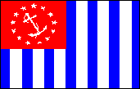
The USPS Ensign was created based on the yacht ensign, but with the colors reversed, and 13 vertical stripes replacing the horizontal ones. It has become the official trade mark of USPS. It can be flown only by USPS members and only in the United States.

During the two world wars, the US Navy accepted an offer from USPS members to train naval officers for Naval Coastal Defense. During World War II, many Naval navigators were trained by USPS members.

The founding of the Phoenix Power Squadron came about by efforts from the squadron’s first commander, the late G. Douglass Young. Doug began his USPS membership in 1940 in the Miami (Florida) Power Squadron.

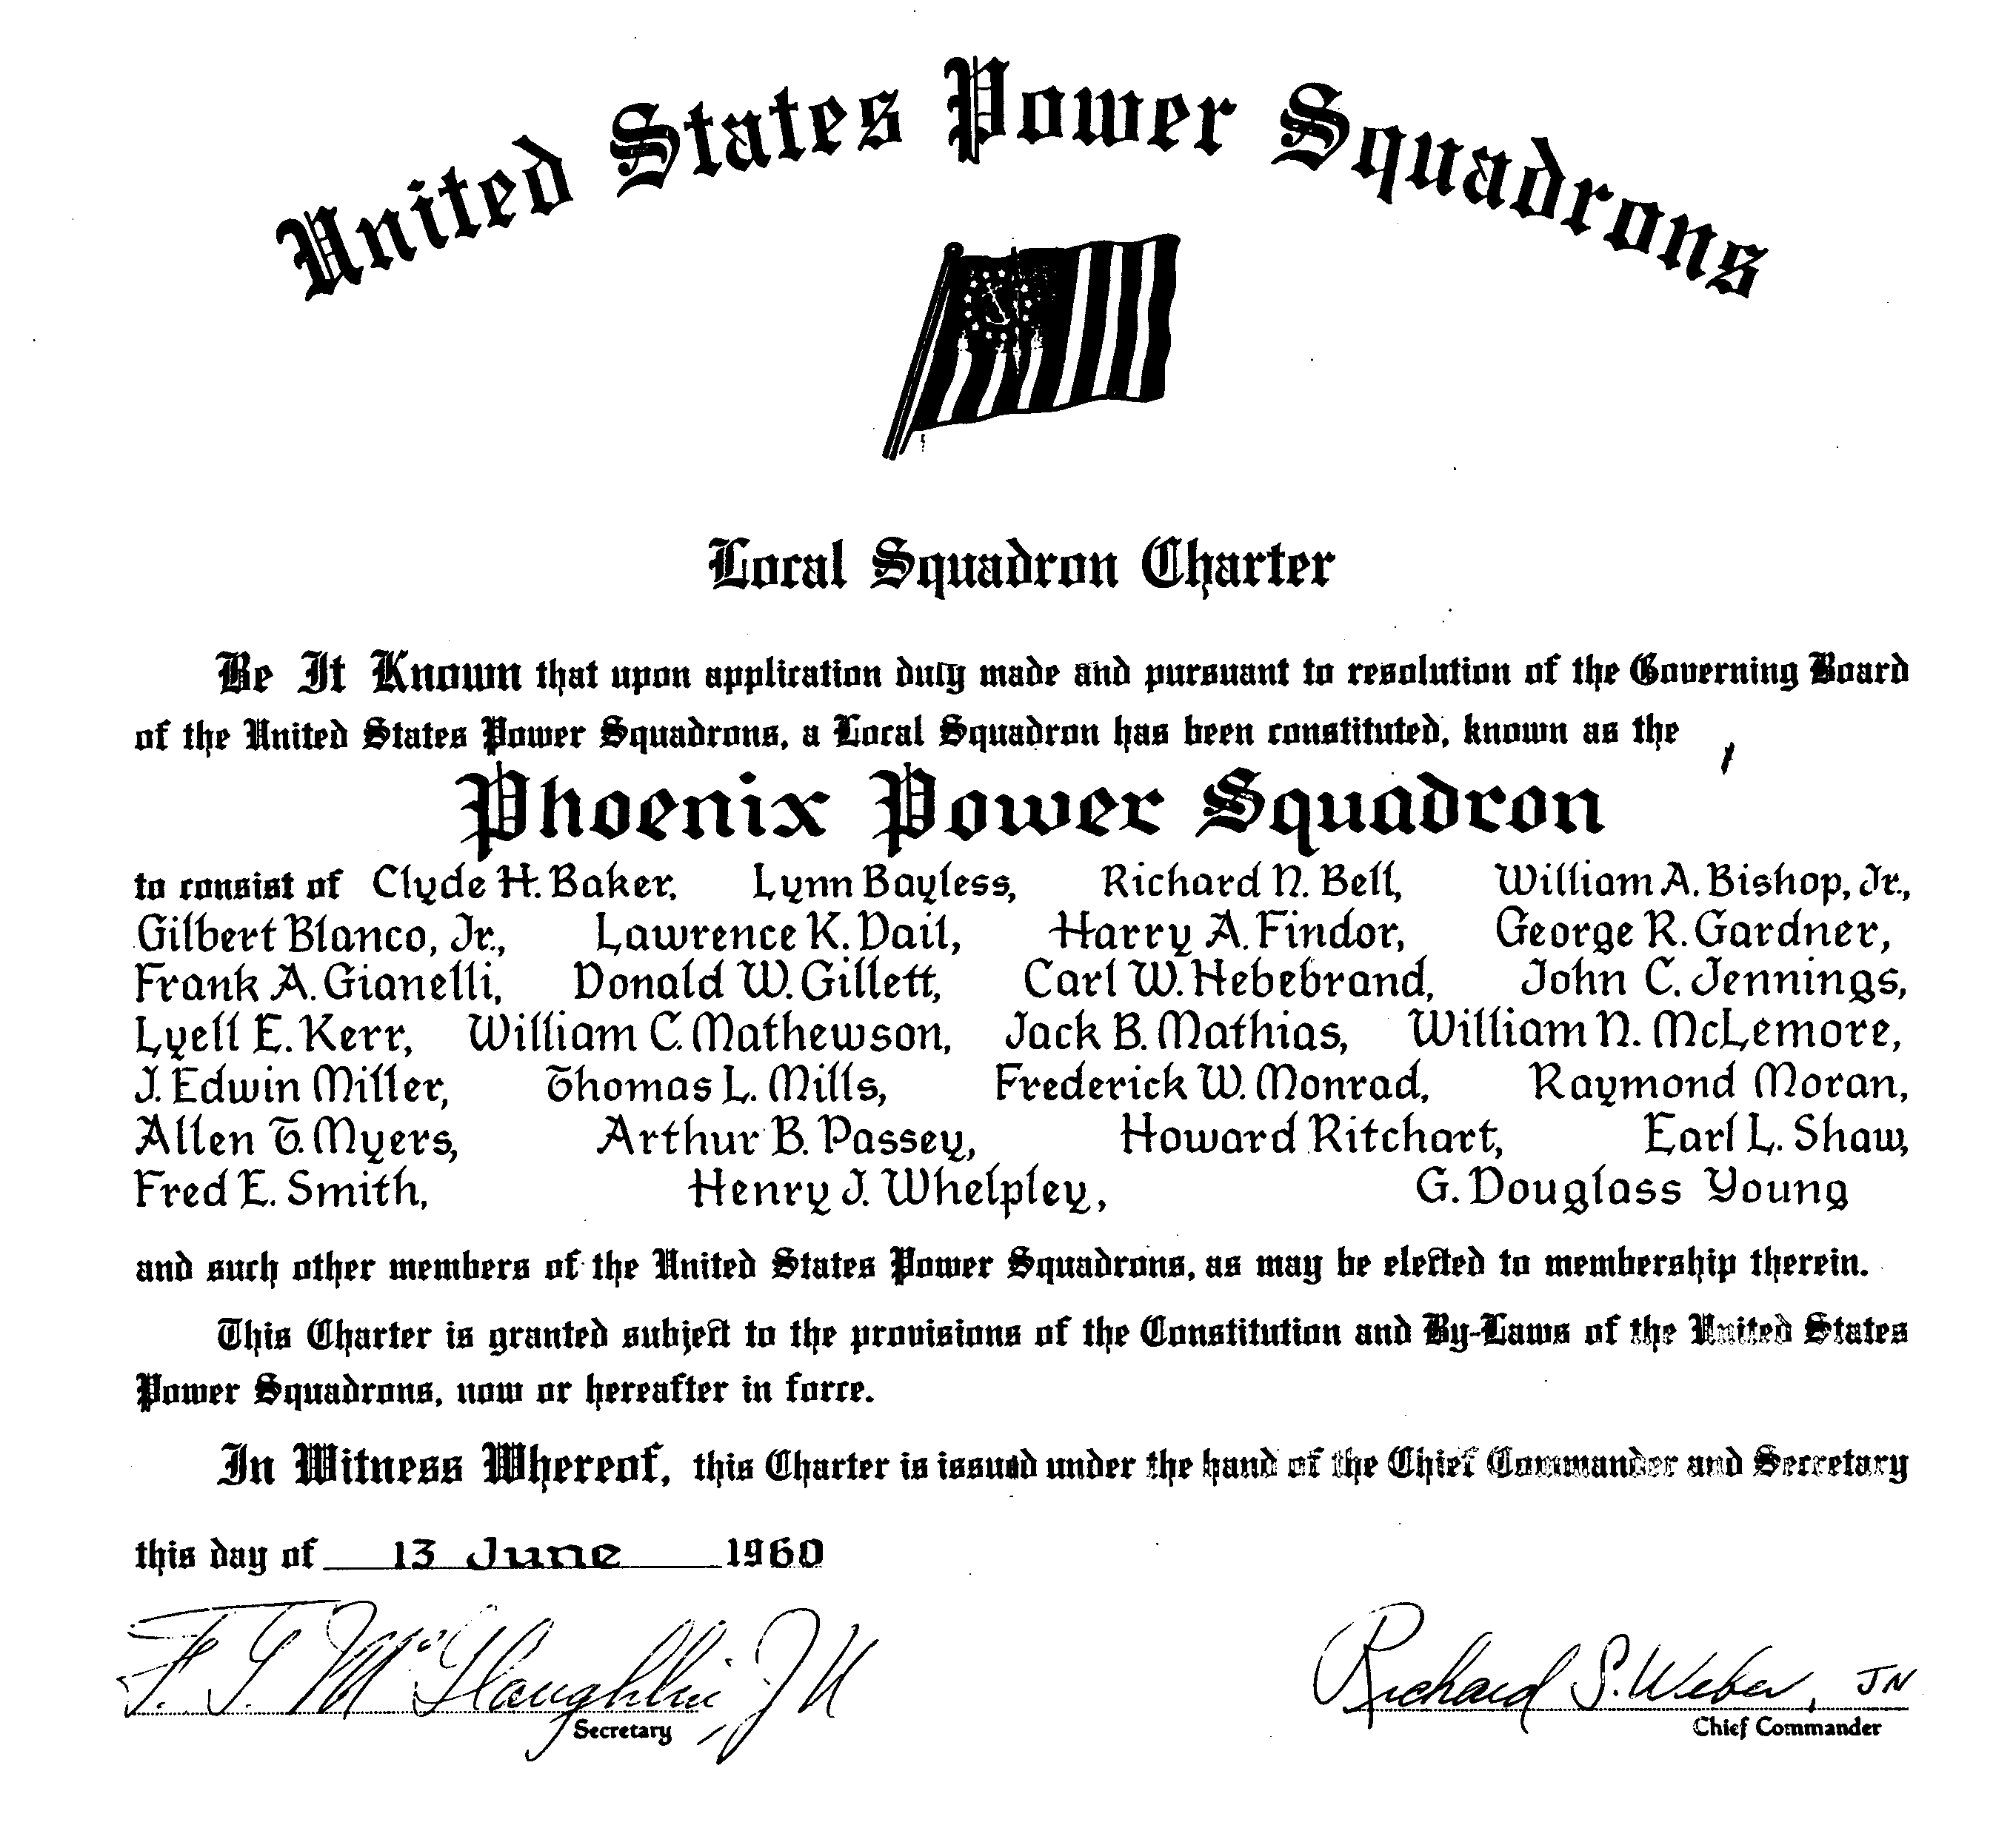

Before a squadron can be approved for chartering, there are certain requirements, such as membership size, a slate of officers, and the approval of a design for its distinctive burgee. This is a holdover from the tradition of yacht clubs, which as we reported earlier, was the basis for forming USPS. There are approximately 450 squadrons, more than 30 districts, and an untold number of yacht clubs throughout the world. Each has a unique design for its burgee, a signal denoting membership.


The design for the Phoenix Power Squadron (as it was known until we changed our name some years ago to Phoenix Sail and Power Squadron) comes with a remarkable pedigree. It was created by Marge and Doug Young. He was the founding commander of the squadron, and she was its “den mother.” Both worked for Fleischer studios, one of the nation’s first producer of movie cartoons, a part of Paramount Pictures. The studio is known for the Betty Boop and Popeye series as well as “...follow the bouncing ball” sing-along cartoons. The company was headquartered in Miami, where both Marge and Doug were associated with USPS from about 1940.


In the early days, the squadron bore the nickname “Thunderbird Squadron,” an homage to the Native American culture which has heavily influenced Arizona’s heritage. Although the legend surrounding the non-automotive Thunderbird differs according to who is reporting, the similarity to the Phoenix, the creature that emerges from its ashes after a bout of self-immolation, can’t be ignored, although we are mixing our legends here. Some say the Thunderbird is a Hopi tradition, supported by numerous ancient petroglyphs.

Some years ago, the Bos’n’s Pipe talked with Marge about the creation. She acknowledged the Thunderbird connection. She said the design began with the standard yacht burgee, and she drew and added the stylized version of the bird. She and Doug chose the same colors used in the U.S. and USPS ensigns.

According to Elsie Clark’s Indian Legends of the Pacific, “The Thunderbird is a very large bird, with feathers as long as a canoe paddle. When he flaps his wings, he makes thunder and the great winds. When he opens and shuts his eyes, he makes lightning. In stormy weather, he flies through the skies flapping his wings and opening and closing his eyes.”

So there it is: Marge Young’s burgee uses as its center piece a noisy bird. It reminds your editor of a Lake Pleasant raft up some years ago. (Note: the “g in burgee is pronounced as the “g” in Gee Whiz!)

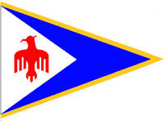
In September 2009 the USPS Flag and Etiquette Committee approved a new design for the Phoenix Sail and Power Squadron burgee. The design acknowledges that the squadron is 50 years old. The change from the original consists of a new golden border one-twelfth in width of the fly to the existing design. Even though the squadron’s anniversary date is June 10, 2010, and is now the official burgee design.

If you were a serious salt water fisherman in the metropolitan Phoenix area, sooner or later you would cross wakes with one of the 27 founders of the Phoenix Sail and Power Squadron. That’s what we learned from Richard N. Bell, N, currently the only living squadron charter member.

Rick and his wife Mary, live today in Alpine, Arizona, and for the first time in too many years to count, he is without a boat. His first was a 12-foot fishing boat frequently seen on Saguaro Lake. A larger boat was needed and that became Merry Belle, a 25-foot power boat he finished in 1959 in his Phoenix back yard. His last was the 50-foot trawler, Endeavor, which he sold just recently.

The origins of the squadron were anchored in serious educational courses, Rick told the Bos’n’s Pipe. The squadron started out as part of the late Los Angeles Power Squadron before it had enough members to be awarded its own charter on 13 June 1960.

Another of the founders, Lynn Bayless, had business in Rick’s neighborhood, and he stopped by one day when he saw Rick completing the Merry Belle project. The two struck up a friendship, and they learned that both were serious salt water fishermen.

They had other things in common and before long they and some other regulars at the Cholla Bay Sportsman's Club near Rocky Point in Mexico, gathered to organize what would become the Phoenix squadron. Education was the common thread, Rick said, and he and Lynn were among the original instructors. They took classes, and eagerly learned everything in the courses. There were no proctors, and when necessary, a Los Angeles PS member would drive over to give the exams. As it turned out, the Phoenix members were getting some of the highest scores nationally among USPS members.

Rick has many stories about the early days of the squadron, including riding out Hurricane Emily in the Sea of Cortez., a storm that sank several shrimp boats.

The philosophy of early members was both practical and inspiring, he said. It was “Time is valuable. Enjoy it.”

How were the lakes around Phoenix for boating? we asked him. “We never went there. We were salt water boaters, and that meant the Sea of Cortez. Lakes were beneath us,” he laughed. Rick noted that members of the squadron rarely cruised together in Mexico, but occasionally, when it was convenient, they would get together for dinner at someone’s home.

Rick and Mary remain active at their mountain home. They met when they were professional dancers, and have performed in many venues in Colorado, Arizona, Mexico, and other places. Recently, when they were live boards in Oregon, they taught ballroom dancing at a senior center near the marina. They are currently conducting weekly dance classes at the Alpine Community Center. When dancing was a part of the annual Phoenix Changes of Watch, their dancing was a show-stopper for the rest of us.

Rick, originally from Smith Center, Kansas, came to Phoenix as one of the first staff members of a new Mesa TV station, channel 12. He stayed with them for 18 years before working in film production, including his own company. He still keeps up with hometown high school heroes, the Red Men, consistently Kansas state football champions.

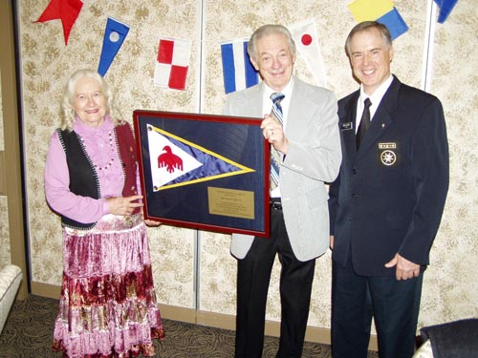
Rick Bell was presented with a 50th anniversary squadron burgee at the 2010 squadron Change of Watch by outgoing Commander David Allocco. Also in the photo is Mary Bell, Rick’s wife and first president of the Spray Mates, the women’s auxiliary which was formed in 1963 and disbanded in 2002.

The anniversary burgee displays the new gold border on the fly of the burgee. Only squadrons achieving a 50th anniversary are permitted to have a gold border.

The presentation contained a plaque which read: “This 50th anniversary burgee is presented to Richard N. Bell, N, founding member of the Phoenix Sail and Power Squadron to commemorate his half century of public service, educational achievement and fellowship.”

Rick was also presented with a recognition plaque from USPS that is given to members who achieve 50 years’ membership in USPS. Through the years, Rick has earned 16 merit marks for service to the squadron and boaters.

Once upon a time, a few decades long ago, the United States Power Squadrons was a male-only-membership organization. No women could be members, but only members could earn a merit mark. In retrospect this seems exceedingly unfair, and it was.

First, a personal story. Your editor has been a member of USPS since the fall of 1975. It was this membership that he brought to Phoenix a few months later, and greatly influenced his life.

Your obedient servant had taken only the basic boating class when the desert became home. After the normal house hunting routine had been completed, a new chore became evident: take Seamanship even before the ink on the mortgage was dry.

There were two wonderful instructors who taught Seamanship and later, Advanced Piloting. They were not members of the squadron because the bylaws prohibited their membership. They were Betty Friedhoff, who remains active today, and the late Marjorie March, widow of Howard March, a past squadron commander.

We met in the upstairs meeting room of Utility Trailers, the then-employer of Bill, Betty’s husband. The rigorous courses were wonderfully taught, the classes were relatively large, and the success rate was high. This was no accident. Betty and Marjorie stayed with their students offering encouragement, special help, and in the case of Marjorie, a retired school teacher, not-so-idle threats if a student was about to fold before the final exam.

How, then, did these two non-members provide such a basic, yet sorely needed service to the squadron? They were holders of “women’s certificates,” a substitute for USPS membership.

Next, a little history. In the mid-1970s, there was some turmoil in USPS over a lawsuit to determine whether USPS was a private organization or a “public accommodation.” The latter designation is what is called a legal “term of art.” Briefly, a public accommodation is like a Greyhound bus terminal. It is private property, but it may not exclude the public which is on that property for the purpose of catching a bus. Other public accommodations would include theaters, hotel lobbies, barber shops and doctors’ offices. So long as an individual is there for the purpose of the setting, no one can be excluded for reasons of race, gender, national origin or other similar reasons.

Because a local squadron in New Jersey had used a public building—a school—to teach the basic Boating class, the definition of the organization was tested in the courts. USPS was declared a private organization, but the trial raised other disturbing questions.

The upshot was USPS bylaws of USPS were changed and in November, 1982, women were admitted to full membership for the first time.

Today, if you look in the Phoenix Sail and Power Squadron directory, you’ll find we have five holders of the women’s certificate. They are
Sandra Barnett, P
Betty Friedhoff, SN
Barbara Lusson, P
Lorraine Peoples, P
Carol Stam

If you take another look in the directory, you’ll also find a listing winners of the Thunderbird Award, the highest honor the squadron can bestow for service to the squadron and safe boating. So honored are Betty Friedhoff, Marge Hill, Adeline Sanderson, and Barbara Lusson.

Once there was an organization within the Phoenix Sail and Power Squadron: a women’s auxiliary called the Spraymates. These hard working spouses sponsored activities and through the years raised funds for much of the equipment we enjoy today. It existed until 2002, when it was dissolved. It was not women only. P/C Jim Hill was a member.

We all owe many thanks to those who did so much for all of us.

There are many reasons members have joined and remained in the Phoenix Sail and Power Squadron during its 50-year history, and for many, the primary reason is the excellent program of continuing education afforded members.

Most are introduced to USPS through the public boating class, successful completion of which was for many years a requirement for membership. With a taste for that, most have continued through Seamanship, Piloting, Advanced Piloting, Junior Navigation and Navigation. Featured are many other courses including Marine Electronics, Engine Maintenance, Instructor Development, Cruise Planning, Sail, and Weather. There are supplemental courses and boating seminars—aimed at the general public—and taught as a public service by squadron members. As a means of increasing professionalism in educational endeavors, instructor certification is a new requirement. Currently the squadron has many certified instructors on its rolls.

How did this come about? The rich tapestry of educational opportunities offered by the Phoenix squadron and squadrons throughout the county did not come by accident. It was one of the founding principles of USPS from the beginning.

First, a glimpse back in time. In the early 1900s, there were two means of propulsion for boats—sail and steam. There was little enthusiasm for gasoline powered boats. Those clunky contraptions were left to the fledgling automobile industry.

U.S. laws governing navigation applied only to steam engines, and steamboat inspectors were “old, crusty sea-going men,” according to the official USPS history. They wanted to have the same rules for ocean liners and other steam-powered vessels to apply to recreational power boats. The need for professionally educated recreational boaters was clearly present. The first requirement for a new member was to pass a fairly stiff examination in advanced piloting subjects. Only then was a member able to fly a distinguishing signal, which was regarded with high esteem. This requirement led to the birth of USPS some years later.

In 1917, three years after the founding of USPS the first official course was created: Junior Navigation. Shortly afterwards, a Navigator course was established.

With the outbreak of World War I, Charles Chapman (yes, that Charles Chapman of Piloting, Seamanship and Small Boat Handling) volunteered the entire USPS instructional program to then Assistant Navy Secretary Franklin Roosevelt, which he accepted with gratitude. More than 5,000 students were trained in New York, and others in Boston, Detroit, Newburgh, NY, New Haven and Washington DC. Many USPS members received commissions based on their nautical skills.

In 1931, Advanced Piloting was added to the educational menu for the 840 members of USPS. After bylaw changes in 1932, the number of members nearly doubled and there were now 12 squadrons.

With the beginning of World War II, USPS once again volunteered its educational program to the nation, and it was accepted by now President Roosevelt. The educational program now included night classes. USPS instructors taught navigation and allied subjects, including Seamanship, which was added in 1942. Weather and Engine Maintenance were added in 1946 along with Instruction Techniques. Ironically, Sail was added in 1953 with Marine Electronics becoming part of the curriculum in 1961. Later, piloting, which had been part of the public boating course became a separate course, and Cruise Planning was eventually added.

Today, USPS is known by its reputation for outstanding instruction, instructors, and informed and knowledgeable members.

Through the years, the Bos’n’s Pipe has evolved, usually reflecting the style preferences of the duly appointed editor. The current version, however, reflects the technology now at the disposal of the current editor.
The front page contains the “banner,” the title of the publication found at the very top. It has looked a little like this since 2003, and it is the only version that has appeared in color through the years:


The illustration below the logotype is a bos’n’s pipe, or as it is sometimes known, a bos'n's call. The word, bos'n's or sometimes spelled bosun’s is short for boatswain, the member of the crew who is responsible for the hull of the ship. It is he (or she) who “pipes” individuals on board a ship. You may have seen this done in motion pictures where someone clasps his (or her) hand around the pipe producing a high-pitched whistle or signal. The pipe was originally used in the navies of the world to give orders above the din of combat.

Who named the publication for the Phoenix Sail and Power Squadron is a mystery to this writer. It was probably one of the original members of the newly chartered squadron in 1960.

The banner has evolved through the years. In 2002, it looked like this:



It reflected what was possible with the use of simple graphic programs available on the computer. While this version was being developed, several approaches were tried. Among them was this one:

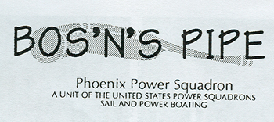

The earlier copy of a Bos’n’s Pipe on hand had this look:


This banner was from a time when the squadron’s nickname was the Thunderbird Squadron, which is one of the key features of the squadron burgee, described in an earlier edition of the 50th anniversary series of the Bos’n’s Pipe.

We were able, however, to find an even earlier copy of the newsletter, this one was Volume 1, Number 4, from August, 1962. Look for the curious thing about this version is the actual name of the newsletter:

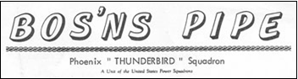

There’s a missing apostrophe. The possessive form of the newsletter name came at some later, after 1980, and probably at the whim of its duly appointed editor.

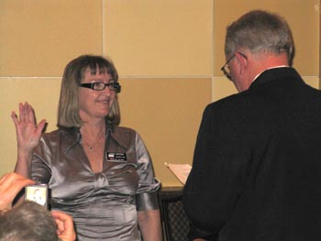
Over the past fifty years, eight members of the Phoenix Sail and Power Squadron have been elected by their peers in District 28 to serve as commander. The most recent is Connie Johnson, who has also served as squadron commander. She was elected at the D/28 Spring Conference, which was held in Phoenix in March.

Connie becomes the first district commander who follows her husband, Bill, who also served first at district commander and later as squadron commander. She has earned 11 merit marks, and enjoys boating with her husband on C Dreams, a 27-foot power boat.

Other district commanders, in order of their service are John E. Redmond, now deceased, who served from 1966-1968. He was squadron commander for the 1963-64 term.

The third district commander is Paul Schoonover, SN, who is in his 50th year as a member of the squadron. During that time he has amassed 49 merit marks, is a life member, and divides his time between his homes in Cave Creek and Puerto Peñasco, Mexico. He boats on Vaya, his 22-foot powerboat.

Frank Fitzgerald, AP, served as district commander from 1982 to 1982. He boats out of San Diego on Wind Tree, a 45-foot Columbia. He also has a home in Prescott. Frank has earned 34 merit marks, and is a life member.

Lee Whitehead, SN, was elected district commander and served from 1990 to 1991. Lee boats on his 22-foot sailboat, Skilligalee. He has 34 merit marks, and is a life member.

Robert W. Schloeman, JN served as district commander at the turn of the century, 2000-2001. He is a past rear commander and has 18 merit marks. He is temporarily boat less. He served as squadron commander 1994-1995.

William A Johnson, SN, was district commander from 2006 through 2007. He was squadron commander after that term, serving two terms as squadron commander, 2007-2009. He has 12 merit marks. He shares C Dreams with Connie.

Charles E. Peterson, SN, succeeded Bill as district commander, and he served from 2007 through 2008. He was squadron commander from 2002 through 2003, and his wife, Jane, later became the first woman commander of the Phoenix Squadron. He has 18 merit marks and has a 20-foot power boat, Another Adventure.

Typically, district commanders rise through the “ladders,” first serving as district treasurer or district secretary, district administrative office, and district executive officer. Some district commanders have also served as district educational officers, but this is not common.

In addition, there are several associate members of the Phoenix squadron who are P/D/Cs. These include Elaine Keller, AP, Balboa; Katherine Law, S, San Diego; Paul Love, AP, and Don Myers, SN, current Phoenix, but formerly of Tucson; and Chester White, SN, San Diego.

For as long as anyone can remember, the planning for the annual past commanders’ barbecue has been held on the patio of Grace and Paul Schoonover’s Cave Creek home, much to the relief of the immediate past commander who was charged with all the planning.

For as long as anyone can remember, the annual Mexico Fiesta, variously called the Cholla Bay Fish Fry, clambake or shrimp boil, has been held on the patio of the Cholla Bay, Mexico home of Grace and Paul Schoonover.

For as long as anyone can remember, when we have trouble remembering the early days of the Phoenix Power Squadron, or more recently, the Phoenix Sail and Power Squadron, there’s been a ready source of knowledge—Grace and Paul Schoonover.
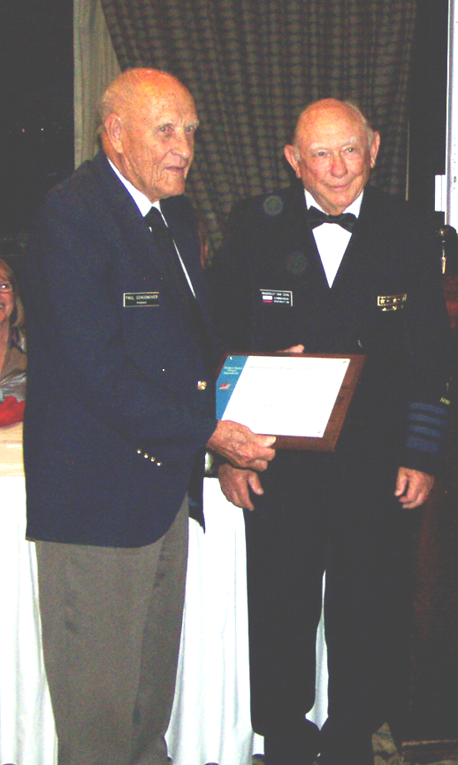

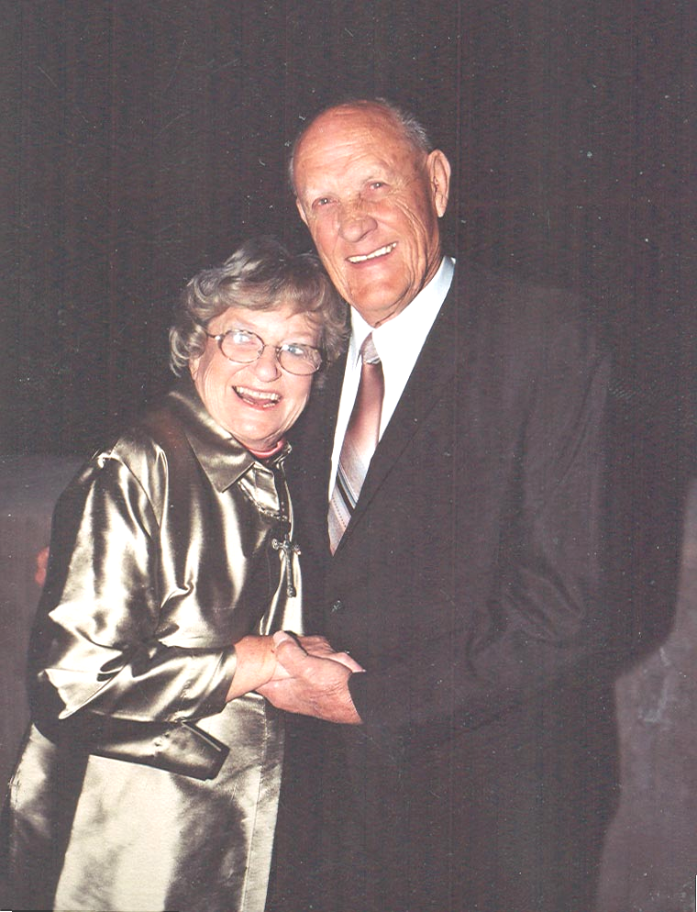

Official recognition—Paul Schoonover was presented with a plaque noting his
50 years service to the United States Power Squadrons.

At the 2010 Phoenix Change of Watch, we learned there was but one of the original members of the squadron still with us: Rick Bell, who with his wife Mary lives in Alpine, Arizona. Had it not been for Paul trying to form a US Coast Guard Auxiliary unit in the Phoenix area at the time, there would have been two of the original founders. Paul missed that distinction by about six months as he joined the squadron in December, 1960, a few months after the founding.

Paul was honored at the last District 28 Fall Conference, when he was recognized for his 50 years’ service to USPS, slightly premature perhaps, but this doesn’t tarnish his contributions.

Paul has earned 49 merit marks in the US Power Squadrons. Do the math: that’s a merit mark for every year he has been a member. He’s the first to acknowledge that the total number of merit marks between him and Grace should be double. Her contributions have been many and generous. The catch is that it was many years after the founding of the Phoenix squadron that membership became open to women.

Paul met Grace when he was on active duty in the Phoenix area. His job was to clean up the mess in the desert where a plane accidentally crashed during training, and she worked in the base office. They married, produced two daughters, Paula and Ann, and he later founded his own air conditioning service company.
Paul is originally from Florida, but he spent some years in Norfolk, Va. He graduated from Maury High School, named after Matthew Fontaine Maury, known as the Pathfinder of the Seas, and the man for whom credit must be given for Chart #1. It seems fitting.

Different chapters in the Phoenix Sail and Power Squadron’s rich history have been presented on these pages. On 13 June, the official date of the squadron’s founding, we begin a second half-century of existence.

USPS was created as part of sail-dominated yacht clubs to recognize the increasing use of gasoline engines in recreational vessels.

Other statistics from a half century escape us at this time. We have no idea how many hundreds (or thousands) of boat operators have learned the essentials of safe boating through the public boating classes. We do not have the means to count the number of senior navigators who learned and subsequently taught the essentials of navigation through the highly regarded educational programs. No one has been able to keep a record of how many lives have been saved since 1960 because there were Phoenix squadron members of the lakes around Phoenix or in the Pacific where so many members enjoy boating.

What is known is the Phoenix squadron and its members have made a big difference.

